Background:

Elastic Compute Cloud (EC2) is AWS’s Infrastructure as a Service product. It provides a range of virtual machines suitable for general purpose and specialized on-demand compute tasks. In this hands-on lab, you will gain experience creating and interacting with an EC2 instance. The lab covers EC2 requirements, the choices available with creating EC2 instances, and the provisioning process itself. By the end of the lab, you will have gained the experience needed to be confident using EC2 in smaller deployments, such as blogs or lower-volume websites.

*Provide the required screenshots with your account ID in them to get full credit for this exercise (25pts)

Problem #1 (5pts):

Create a Default VPC (If not already in your account)

1. Navigate to **VPC** > **Your VPCs**.
2. Select **Actions** > **Create default VPC**.
3. Click **Create default VPC**.

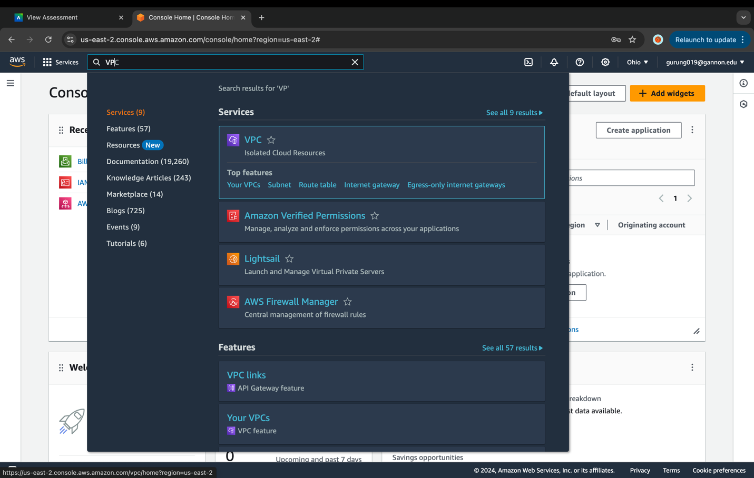

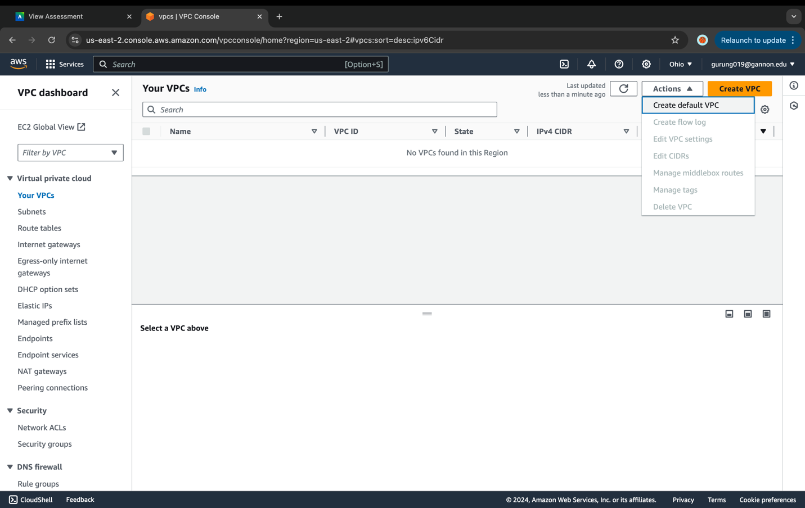

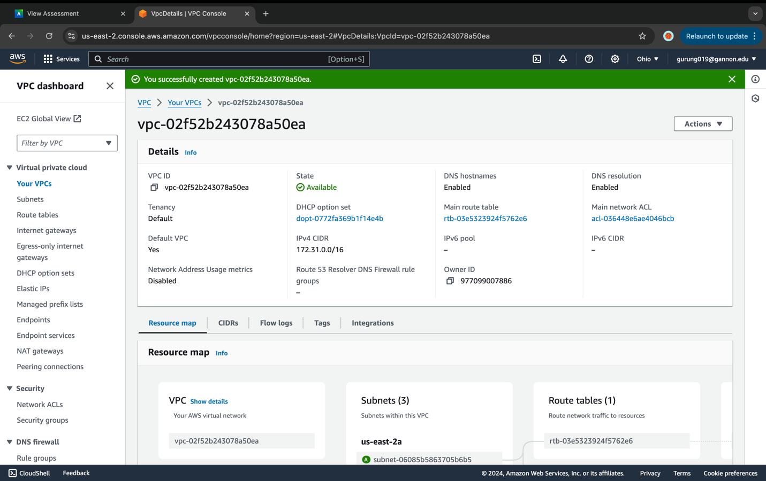

Create an EC2 Instance

1. Navigate to **EC2** > **Instances**.

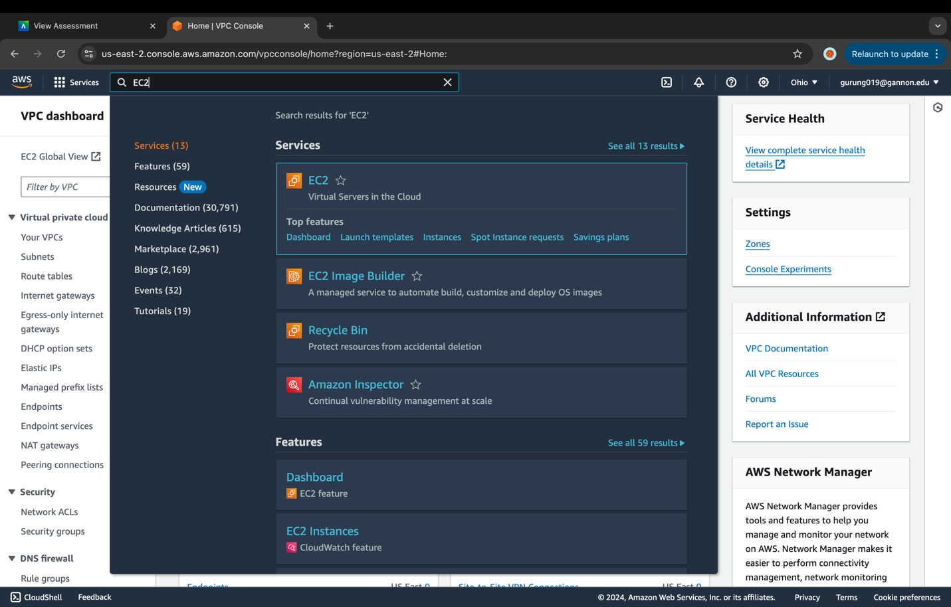

1. Click **Launch instance**.

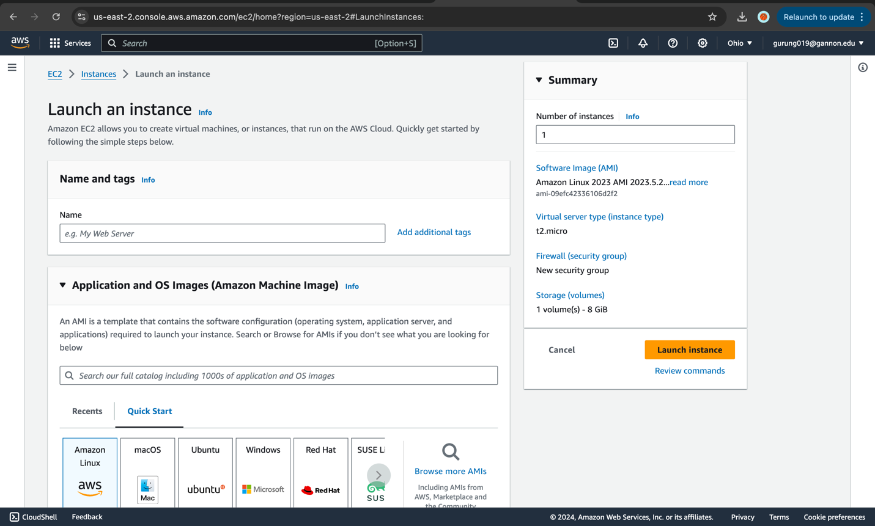

1. On the AMI page, select the **Amazon Linux 2 AMI**.

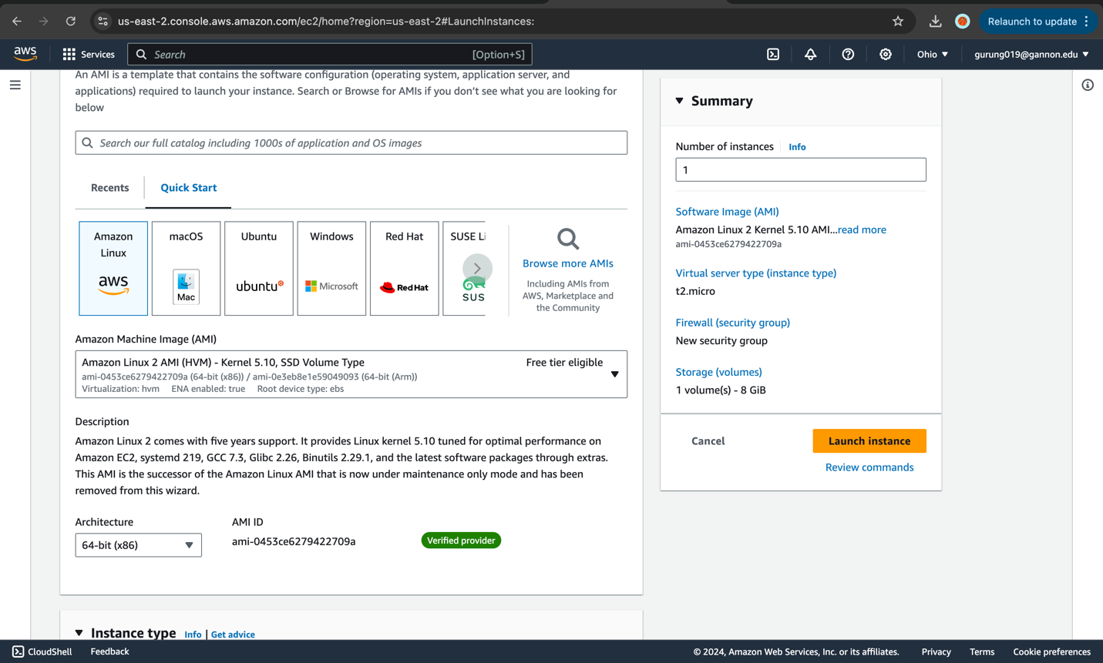

1. Leave t2.micro selected, and click **Next: Configure Instance Details**.

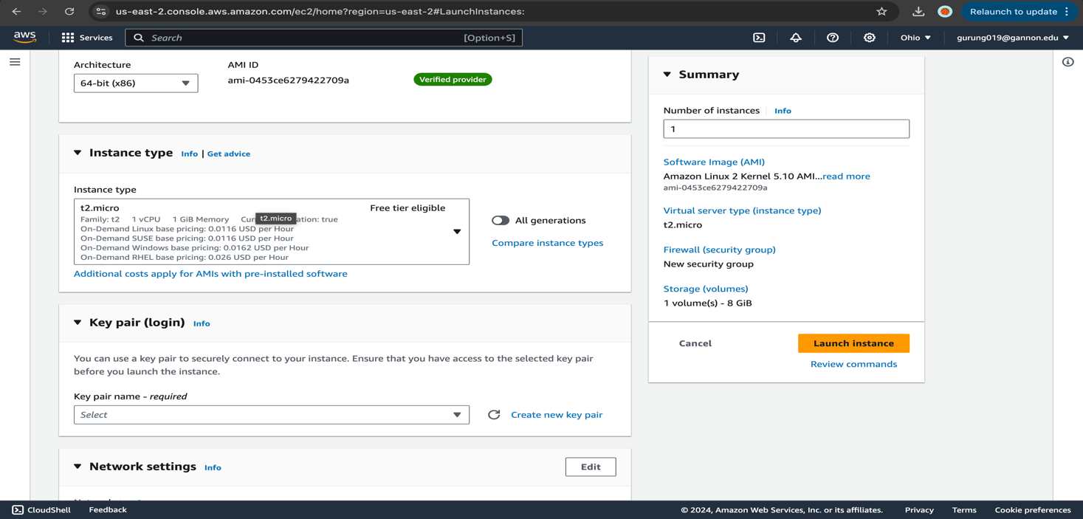

1. On the Configure Instance Details page:
   * Network: **default**
   * Subnet: **No preference**
   * Auto-assign Public IP: **Enable**

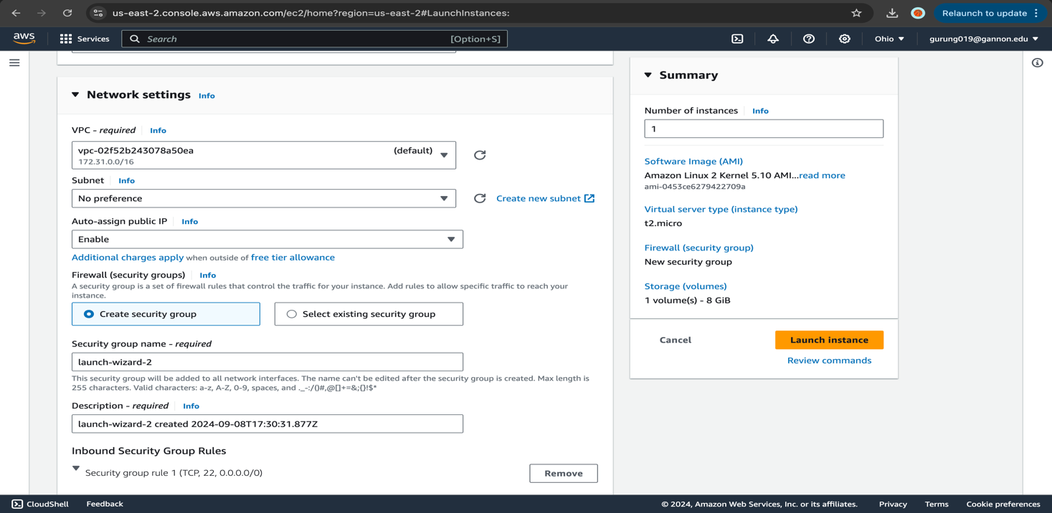

1. Expand Advanced details, and paste the following into the user data box:

#!/bin/bash

yum update -y

yum install -y httpd

yum install -y wget

chkconfig httpd on

cd /var/www/html

service httpd start

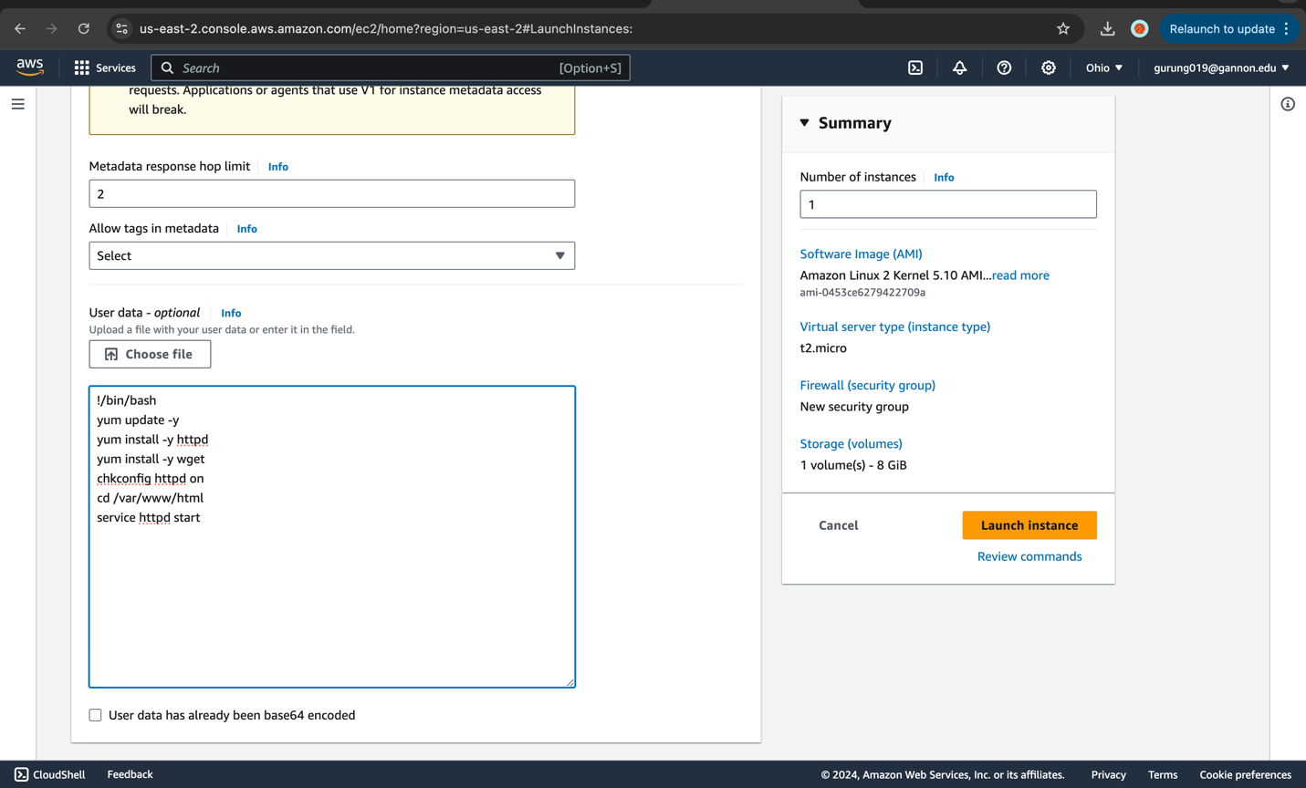

1. Click **Next: Add Storage (leave defaults)**, and then click **Next: Add Tags**.

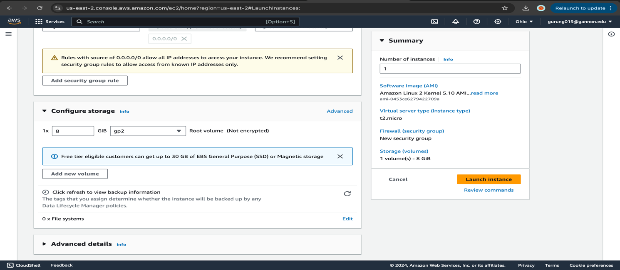

1. On the Add Tags page, select **Add Tag** then add the following:
   * Key: **Name**
   * Value: **Webserver**

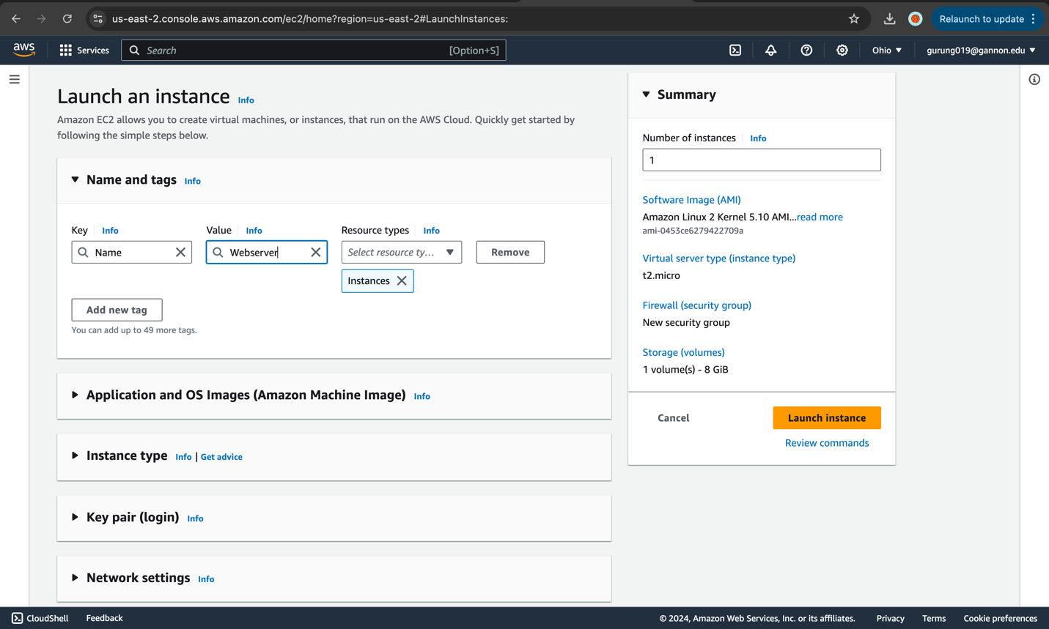

1. Click **Next: Configure Security Group**.

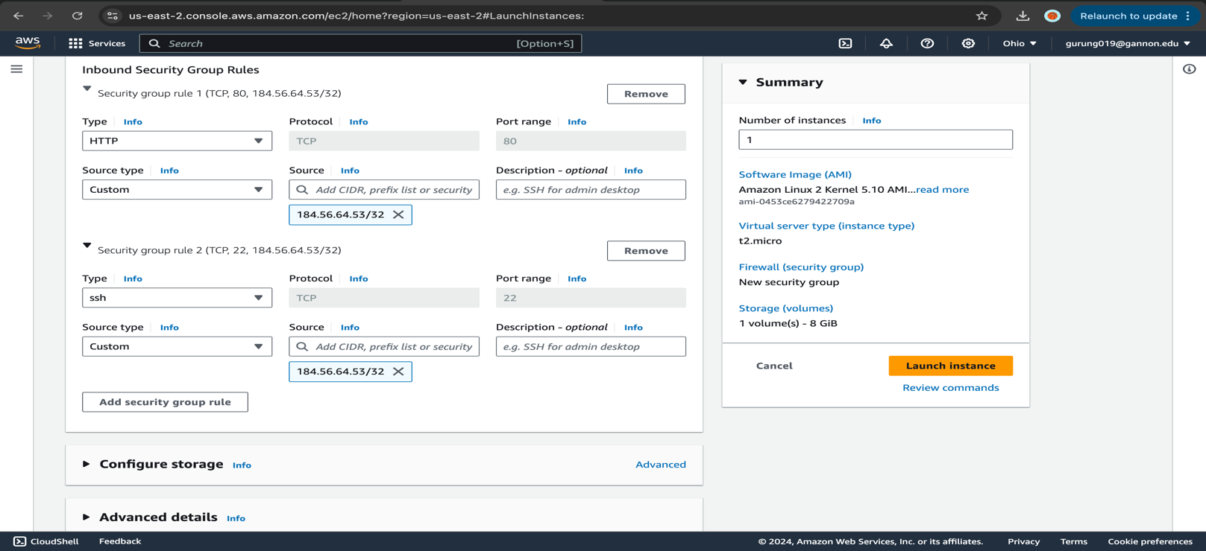

1. On the Configure Security Group page, click **Create a new security group**, and set the following values:
   * Security group name: **LabSG**
   * Description: **LabSG**
2. Click **Allow**, and set the following values
   * **HTTP, SSH from the internet**
   * Source: Your **public IP from (**<http://ipchicken.com>**) /32**

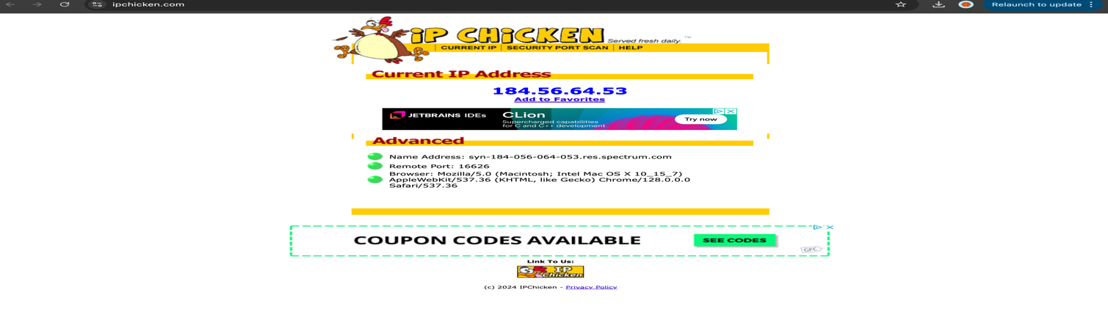

1. Click **Review and Launch**, and then **Launch**.
2. In the key pair dialog, select **Create a new key pair**.
3. Give it a Key pair name of "Lab".

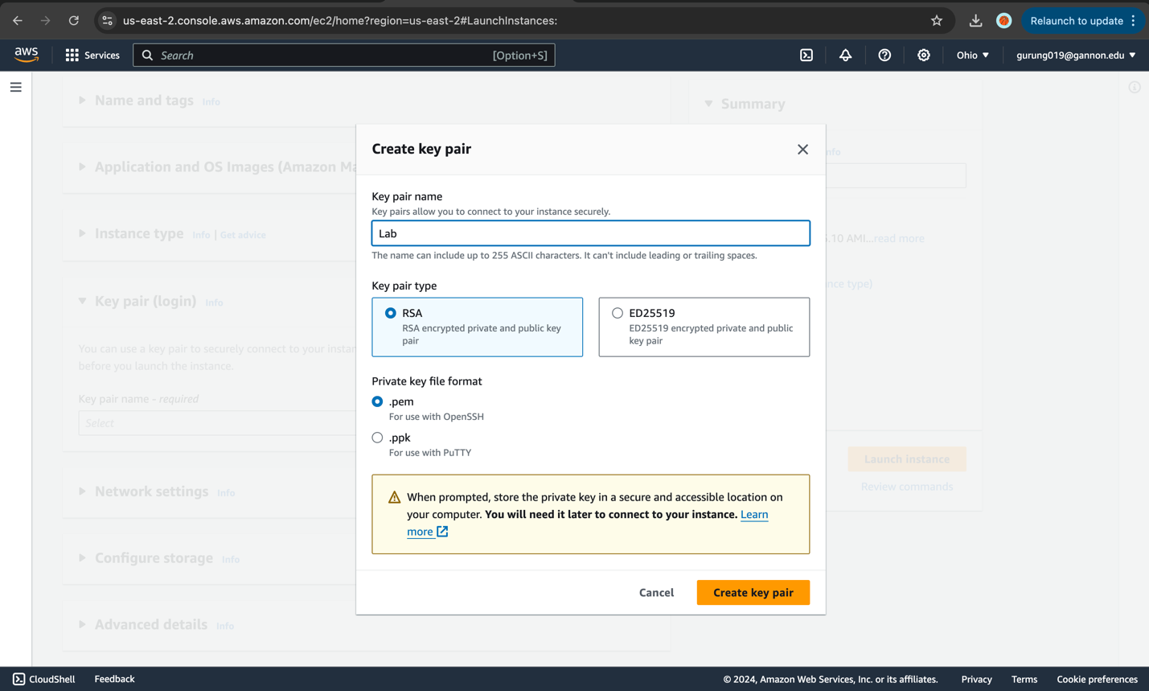

1. Click **Download Key Pair**, and then **Launch Instances**.

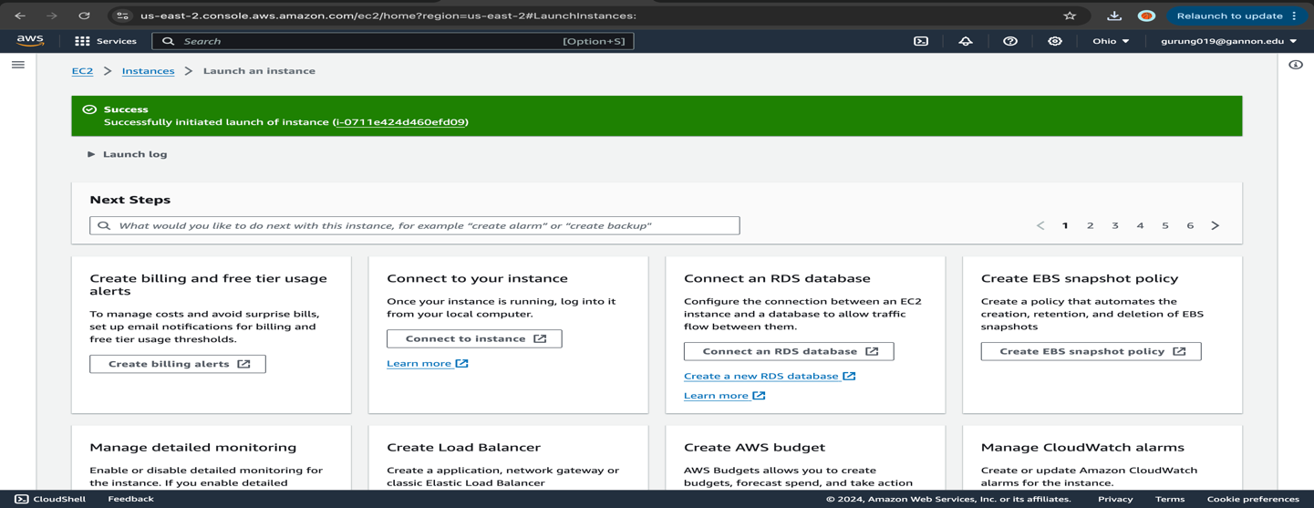

1. Click **View Instances**, and give it a few minutes to enter the running state.

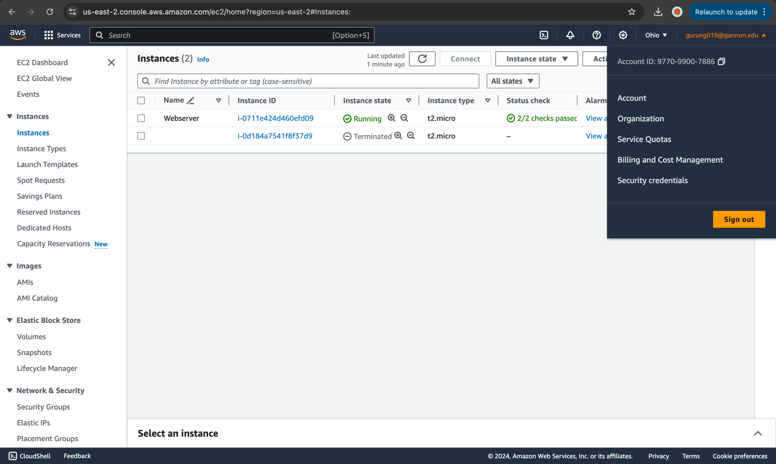

*Please provide a screenshot with your unique account id and you’re running EC2 instance details.  
*You will navigate back to the EC2 service and click instances from the left menu to get this screenshot.

PLEASE LEAVE THE EC2 RUNNING UNTIL THE END OF PROBLEM #2

Problem #2: Manage the EC2 Instance (5pts):

Once the instance is running with 2/2 status checks:

1. Copy the instance’s public (IPv4) address, and paste it into a new browser tab.

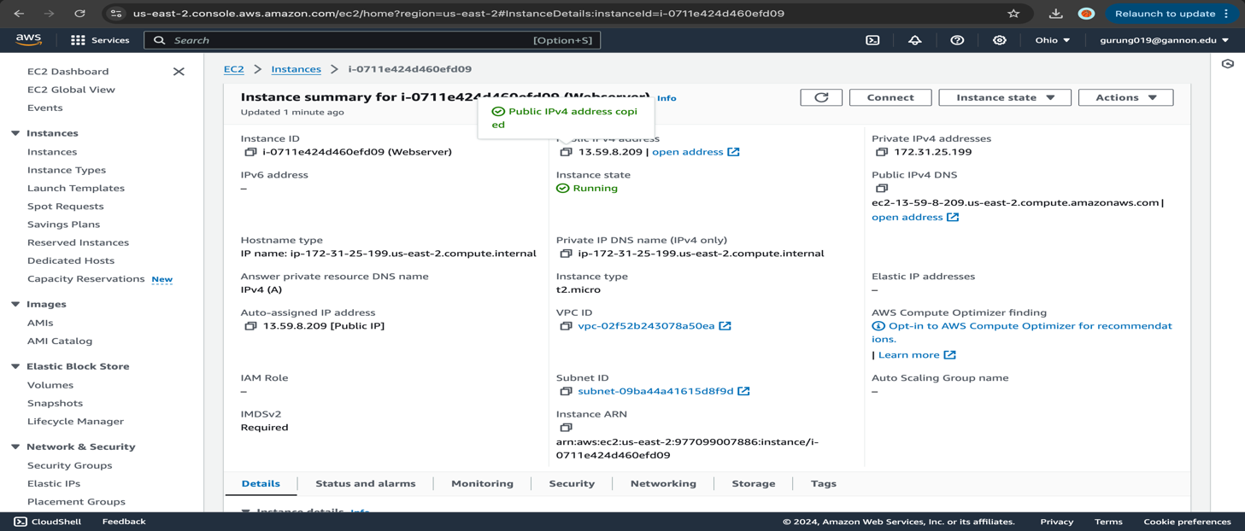

1. On the EC2 instances console, right-click the instance, and select **Connect**.

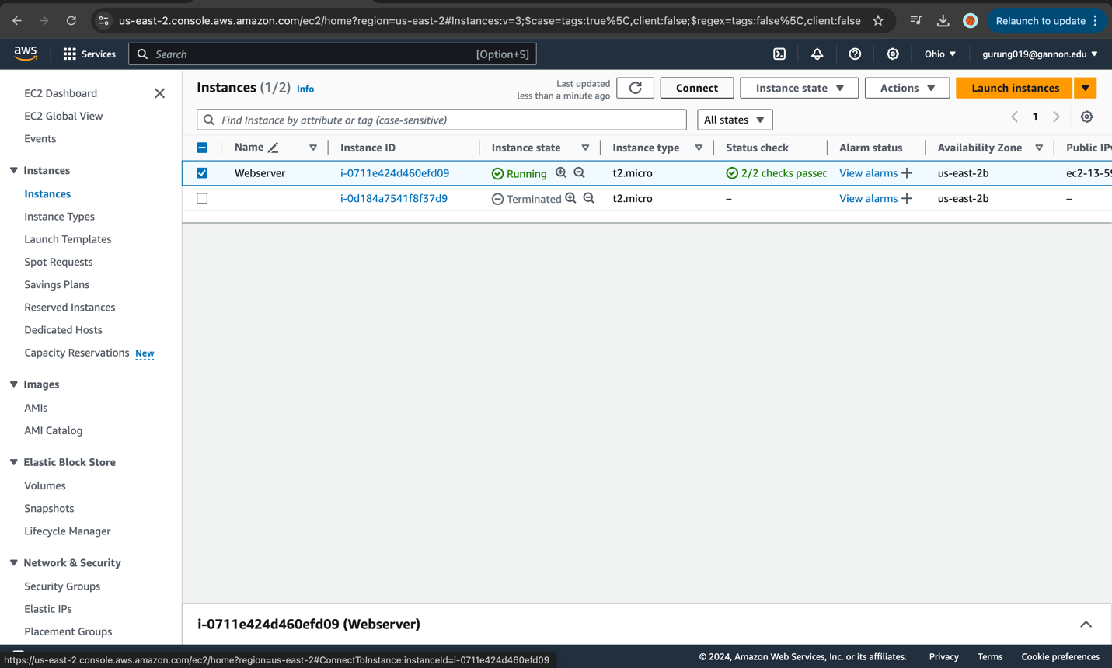

1. In the a terminal (Linux/OSX), change to your downloads directory (e.g., cd Downloads).

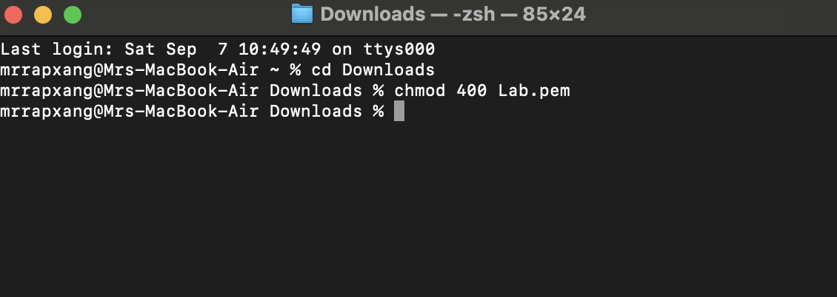

1. Run chmod 400 Lab.pem to adjust the permissions on the file (Linux/OSX Only).
   * If using Windows, you will need to follow the [instructions found here](https://docs.aws.amazon.com/AWSEC2/latest/UserGuide/putty.html).
2. Connect to the instance using the ssh command provided in the dialog when you click **Connect** (or using the PuTTY instructions).

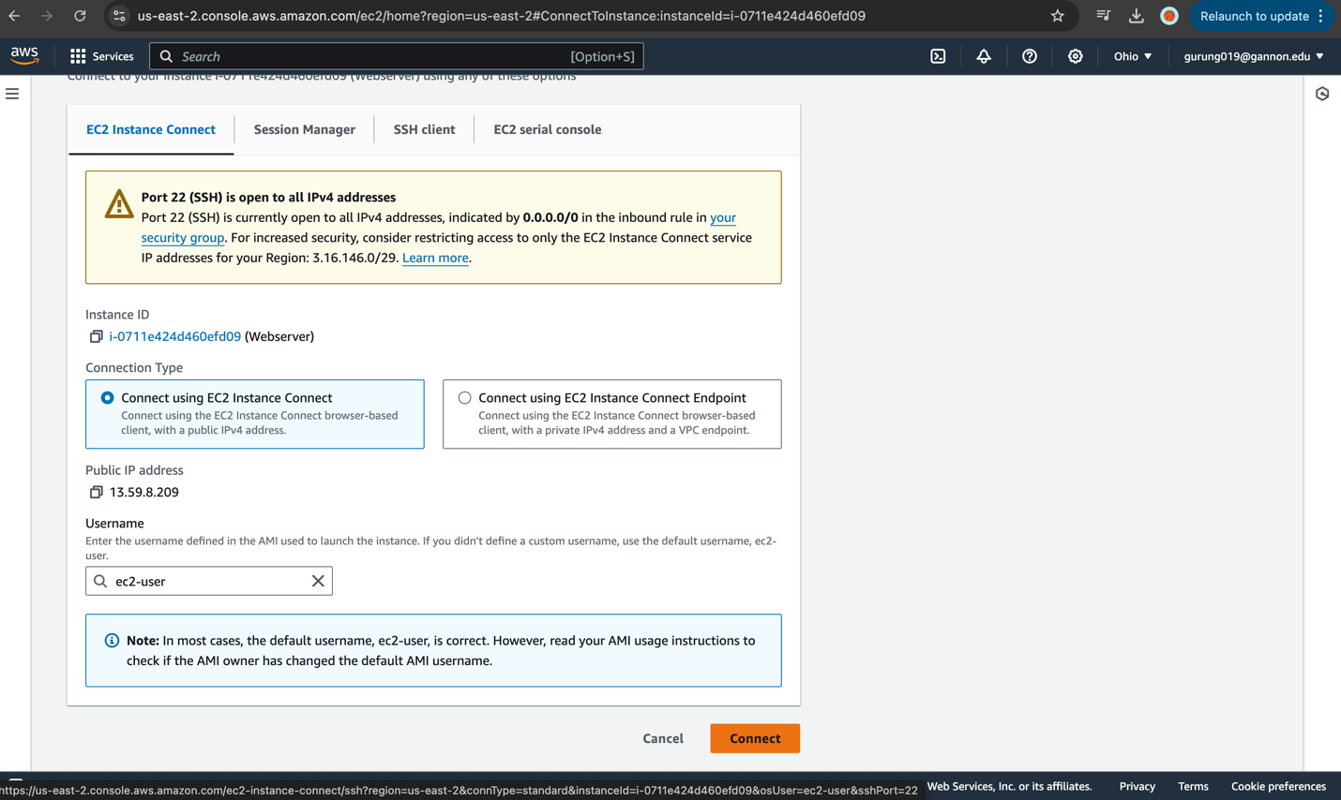

1. Note the IPv4 public IP of the EC2 instance.

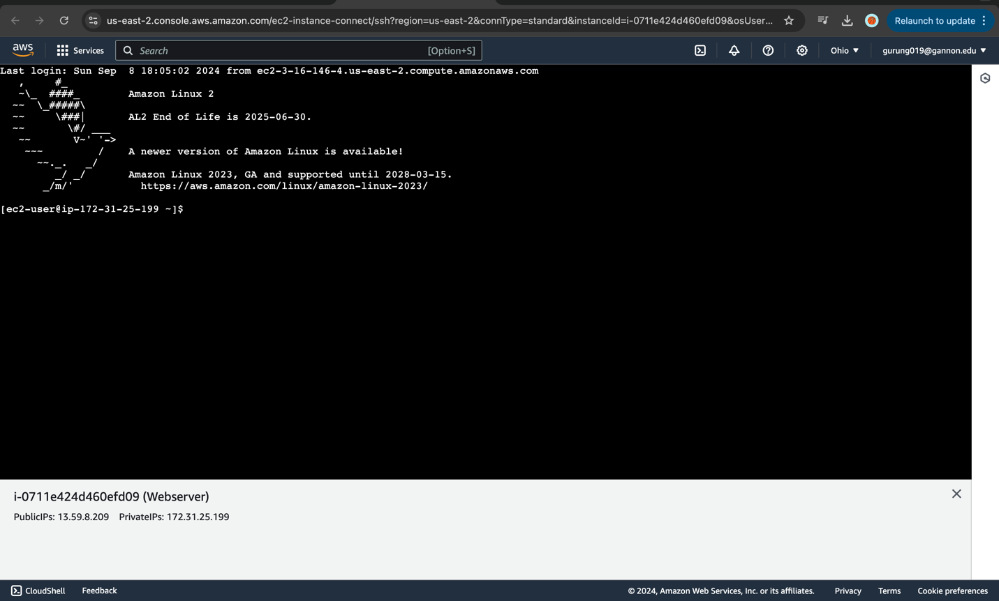

Public IP = 13.59.8.209

1. With the instance selected, click **Actions** > **Instance State** > **Reboot**.

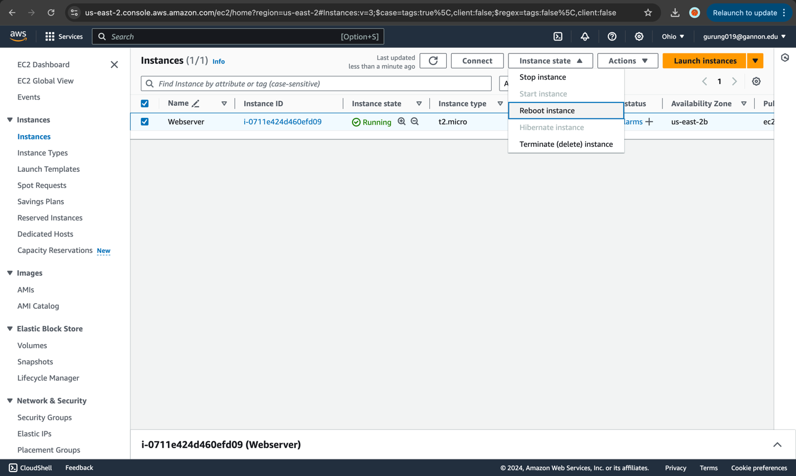

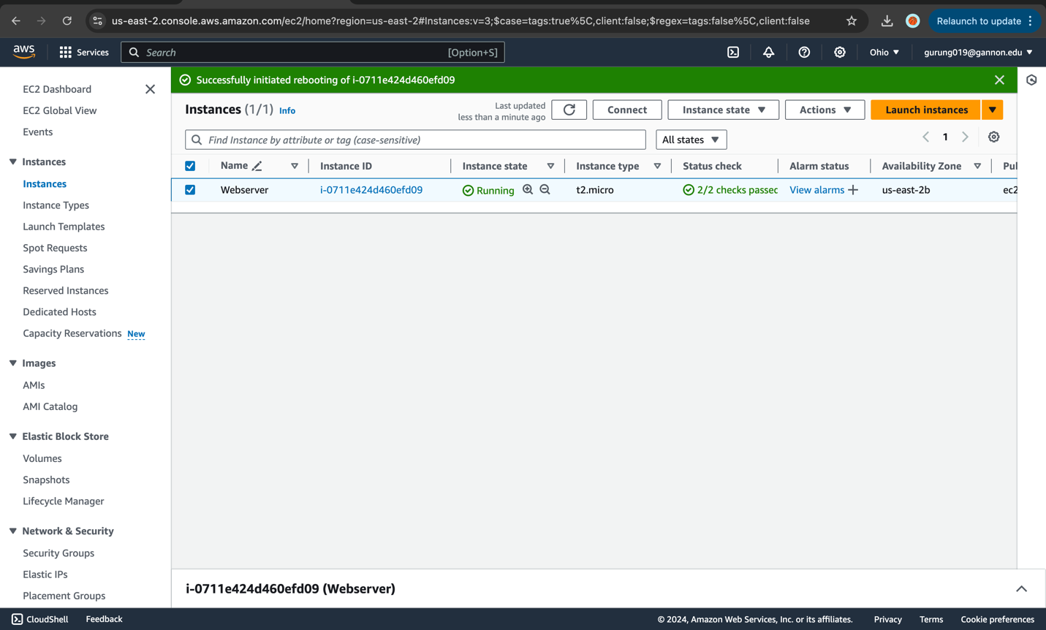

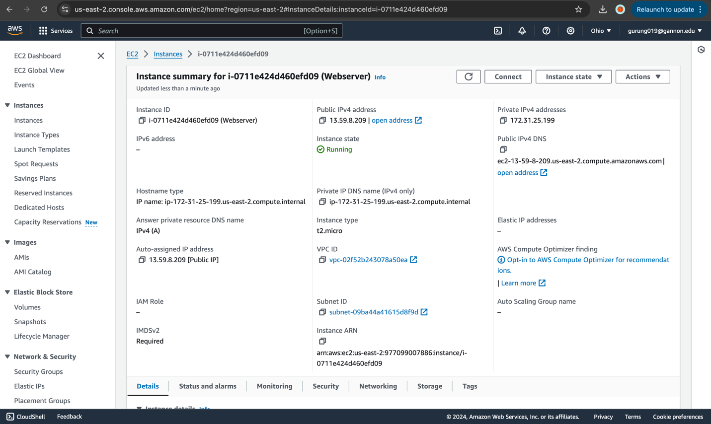

* + Answer for credit: Does the IP change?
  + No, the IP did not change. It remained same as 13.59.8.209

1. Click **Actions** > **Instance State** > **Stop**.

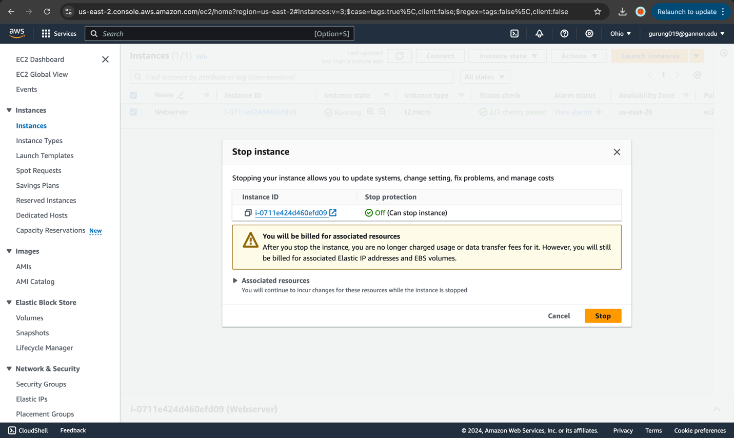

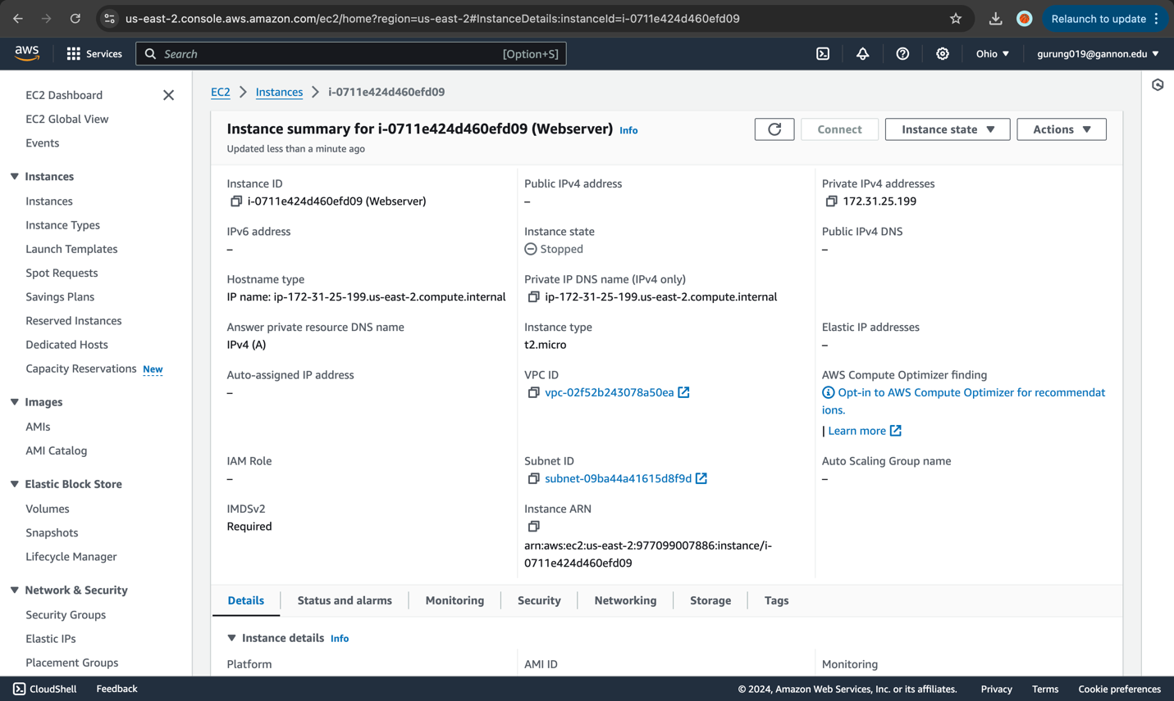

1. After it’s stopped, click **Actions** > **Instance State** > **Start**.

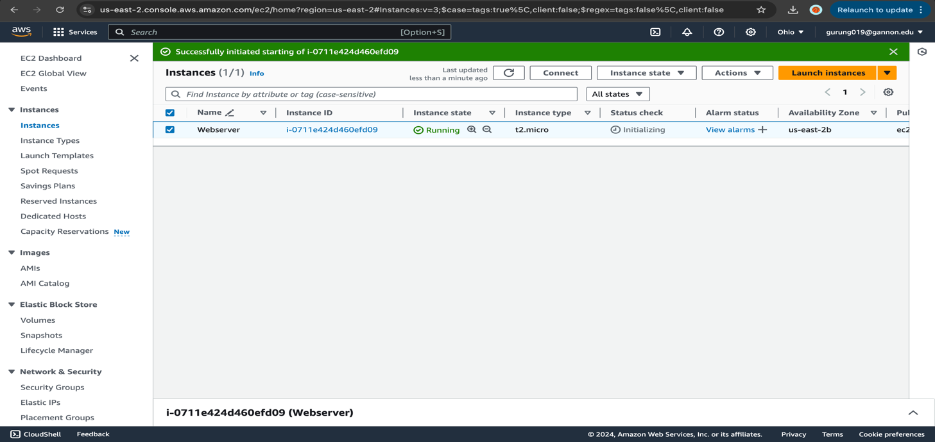

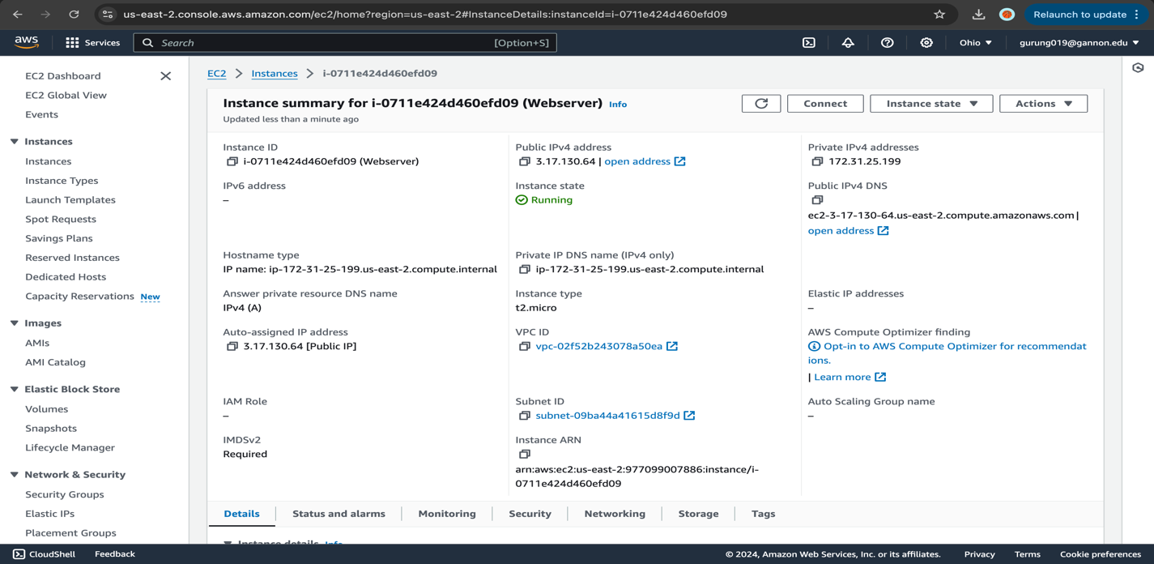

New IP = 3.17.130.64

* + Answer for credit: Does the IP change?
  + Yes, the IP changed to 3.17.130.64

**Please fill in to complete the exercise**

Student Name: Kunga Nyima Gurung

Gannon Email: gurung019@gannon.edu

*Please provide screenshots of running EC2

Modified instance size

Default VPC Overview

Also, an active SSH connection to the instance via SSH

Problem #3: Change EC2 Instance Size (5pts):

1. Under EC2 > Click **Actions** > **Instance State** > **Stop**.

Once it’s stopped, click **Actions** > **Instance Settings** > **Change Instance Type**.

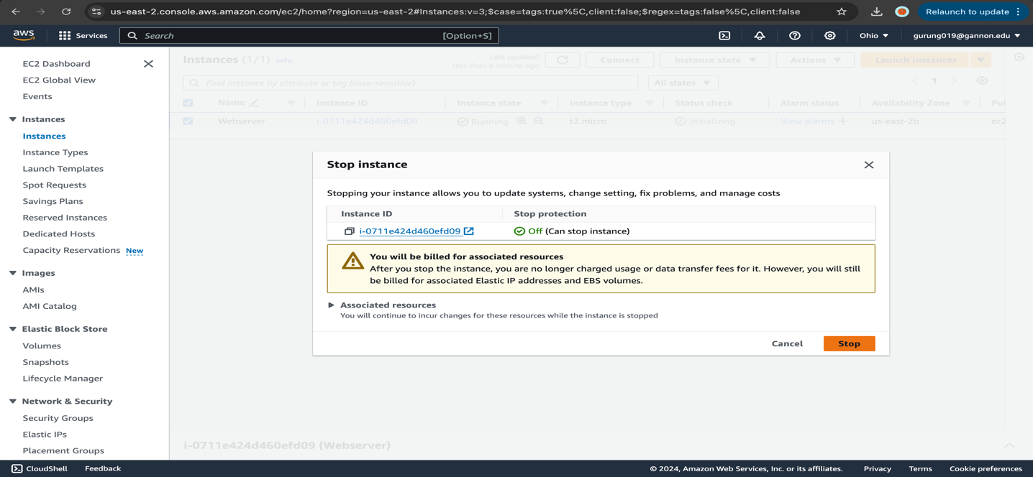

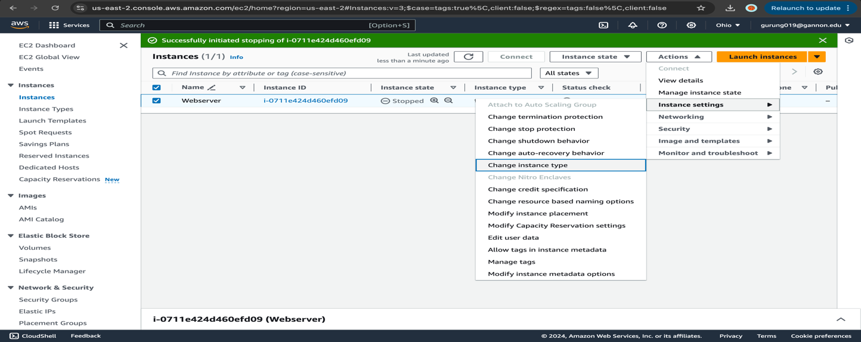

1. Change the instance type to **t3.small**, and click **Apply**.

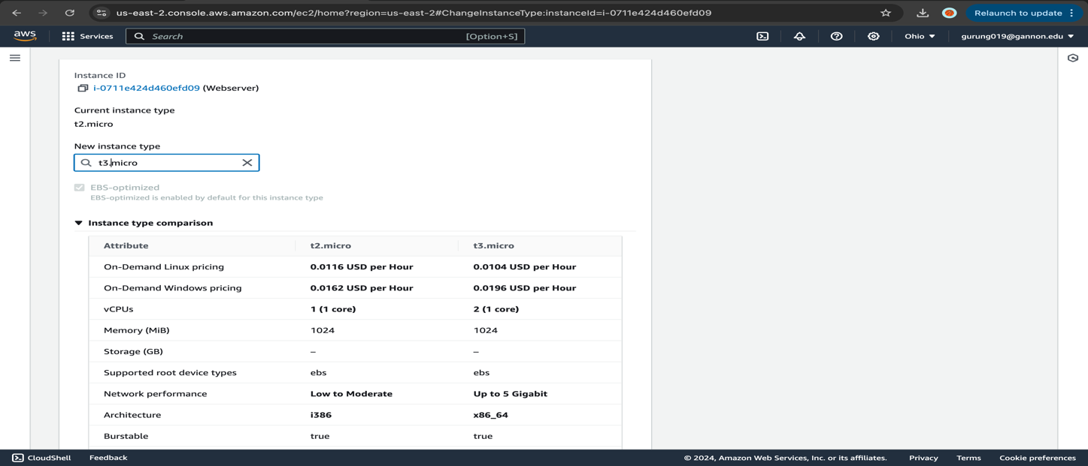

1. Screenshot the instance size change on the EC2 console

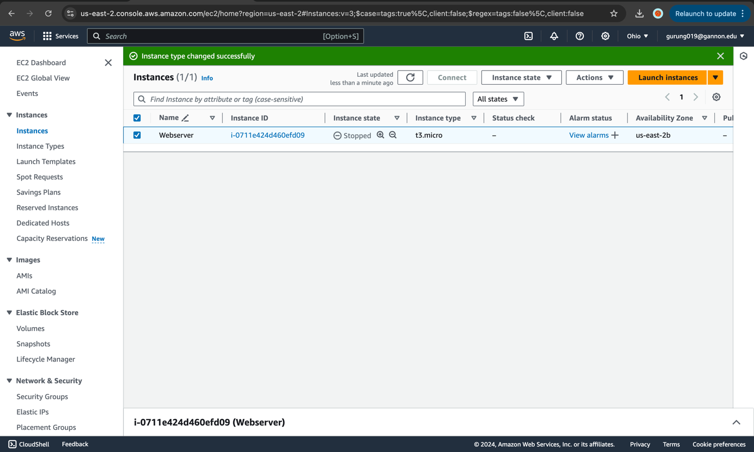

1. Destroy your EC2 instance to save on usage cost

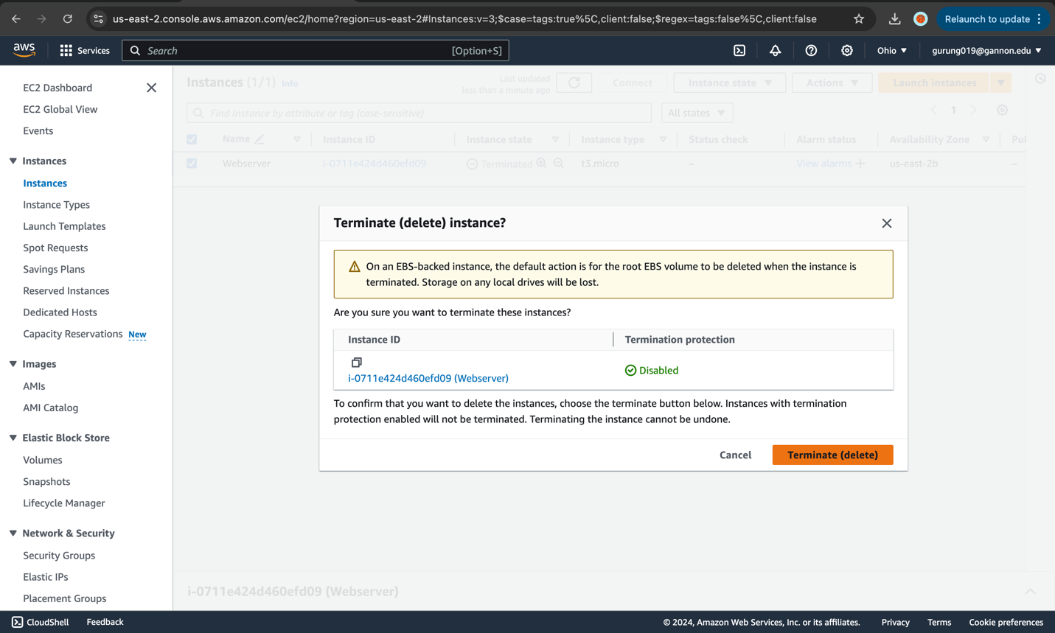

**Please fill in to complete the exercise**

Student Name: Kunga Nyima Gurung

Gannon Email: gurung019@gannon.edu

*Please provide screenshots of running EC2 with the modified instance size

Problem #4: Delete EBS Volume from your EC2 Instance:

Under EC2

Navigate to EBS

>Volumes

*Detach your volume for the EC2 not that is not being used.

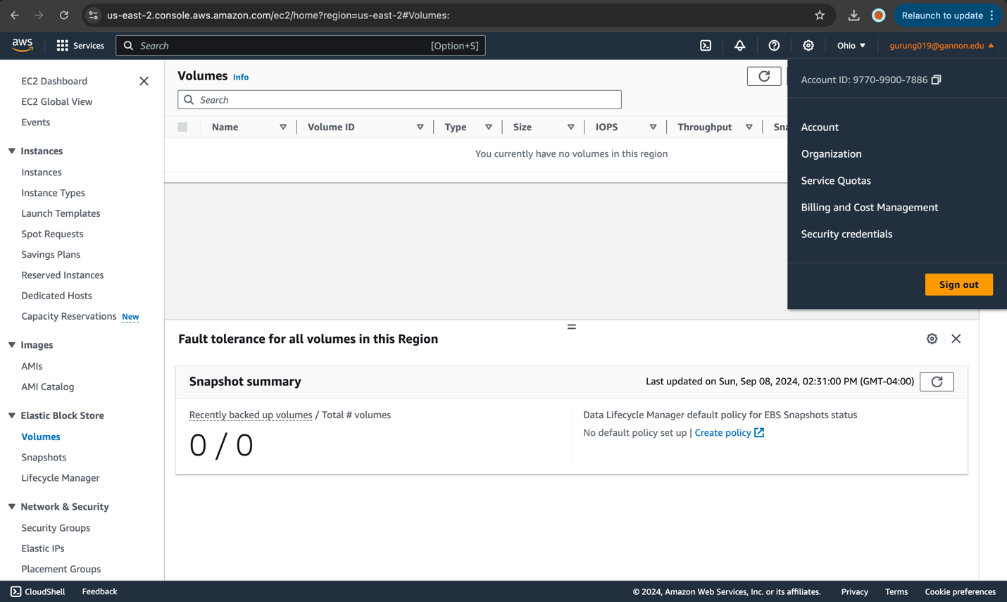

*Please provide a screenshot of zero EBS volumes in your AWS account with your account id in

the corner

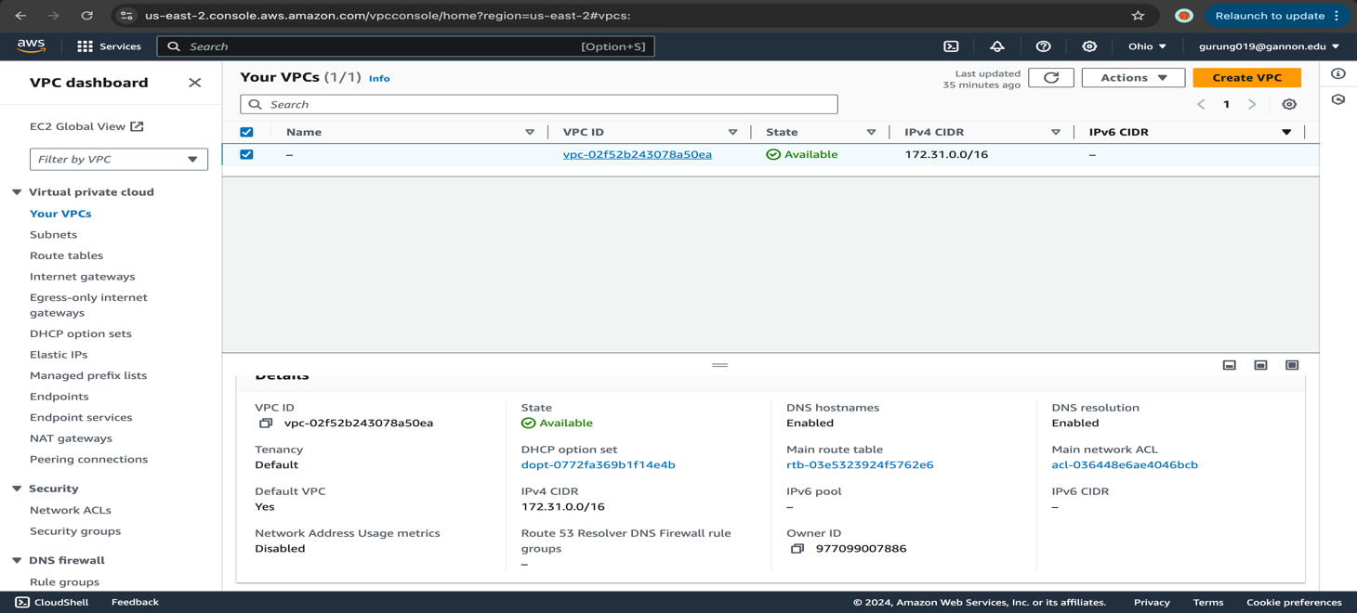

Problem #5 Written Response (5pts):

Please describe in 2-4 paragraphs how availability zones and regions enable you to provision EC2 instances?

Answer:

Because of Amazon EC2's availability zones and regions, users can provision EC2 instances by storing instances and data in many locations. Amazon EC2 has several locations, including Wavelength Zones, AWS Outposts, Availability Zones, Local Zones, and AWS Regions. These zones make it easier to distribute resources, operating models, native AWS services, and infrastructure to locations closer to end users. Even though AWS operates state-of-the-art data centers, failures could affect instance availability. (AWS, 2024)

Region:

Amazon regions are defined as geographical areas having separate power, cooling, and networking. They can failover workloads to other zones within the same region using a technique known as "Multi-AZ" redundancy. Fault tolerance and replication are achieved by connecting these regions over low-latency connections. (Degani, 2024)

Availability zones:

To ensure security and reliability, distribute your Auto Scaling group across multiple Availability Zones in your region and use a load balancer to distribute traffic. Amazon EC2 Auto Scaling creates new instances in unaffected zones when an existing one becomes unavailable and redistributes application instances fairly when the unhealthy zone returns to health. Elastic Load Balancing assigns a load balancer node to each Availability Zone, while cross-zone load balancing evenly distributes traffic over all zones. (AWS, 2014)

# References

AWS. (2014). *Amazon EC2 Auto Scaling.* Retrieved from AWS: https://docs.aws.amazon.com/autoscaling/ec2/userguide/as-add-az-console.html

AWS. (2024). *Amazon Elastic Compute Cloud.* Retrieved from AWS: https://docs.aws.amazon.com/AWSEC2/latest/UserGuide/using-regions-availability-zones.html

Degani, A. (2024). *NetApp BlueXP*. Retrieved from AWS Availability Zones, Regions, & Placement Groups Explained: https://bluexp.netapp.com/blog/aws-availability-zones-architecture-how-to-select#:~:text=A%20region%20represents%20a%20separate,they%20would%20not%20be%20available.